
School of Computer Science and Artificial Intelligence, SR University

Course Code | Course Title | L | R | P | Cr
25CAI202PC  501 | Advanced Data  Science | 2 | 0 | 2 | 3
Program Core

MACHINE LEARNING LAB TEST

Time : 2 hours Total marks : 20

Dr. Sumit Kumar Singh Associate Professor
Submited By: Suvikhyath Thirunahari
Roll No: 2503B05202

Question 1 (10 Marks)

Using the dataset “KNN_regression_dataset.xlsx”, perform the following tasks:

- Load the dataset and display summary statistics of all features.
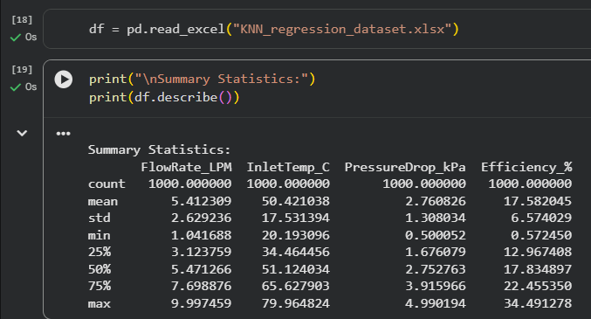

- Split the data into 80% training and 20% testing sets.
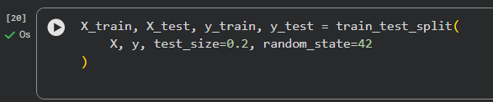

- Standardize/scale the input features appropriately.
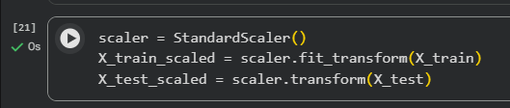

- Build a KNN Regression model with k = 5 to predict Efficiency (%).
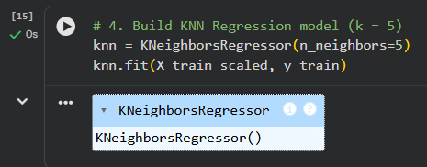

- Use the model to predict the target values for the test set.
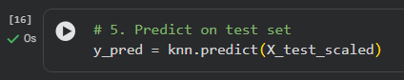

- Calculate and report the following evaluation metrics:
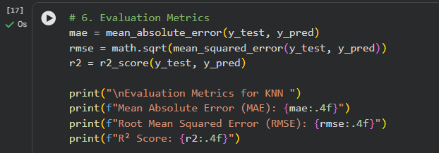
  - Mean Absolute Error (MAE)

  - Root Mean Squared Error (RMSE)

  - R² Score OUTPUT:
Code:
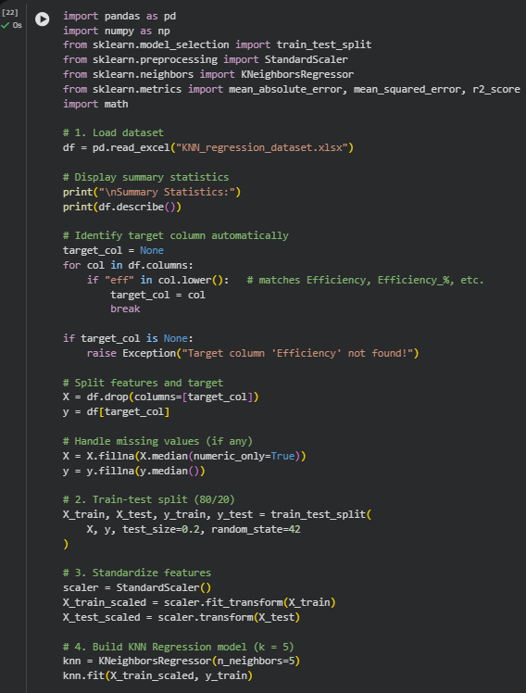
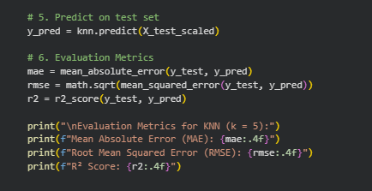
OUTPUT:
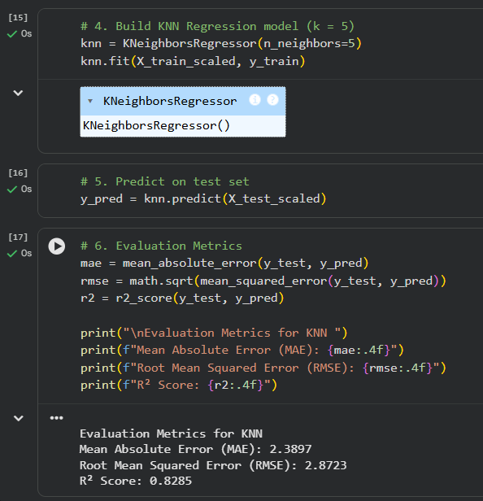

Question 2 (10 Marks)

Study the effect of different k-values on the performance of KNN Regression using the same dataset.

- Train four separate KNN Regression models with:

k = 1, 3, 5 and 10
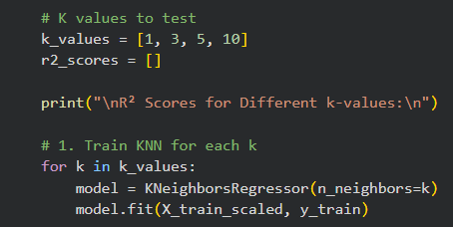

- For each model, compute and record the R² Score on the test data.
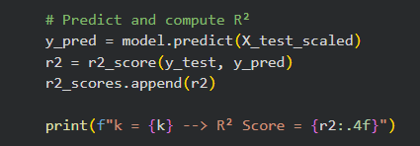

- Plot a graph of k vs R² Score.
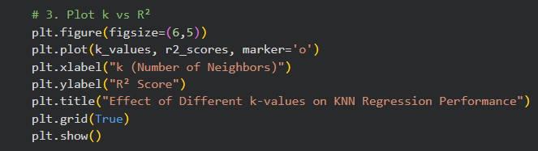

- Identify which value of k gives the best performance.
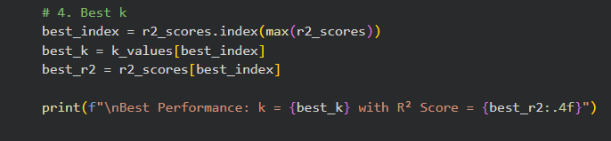
OUTPUT:
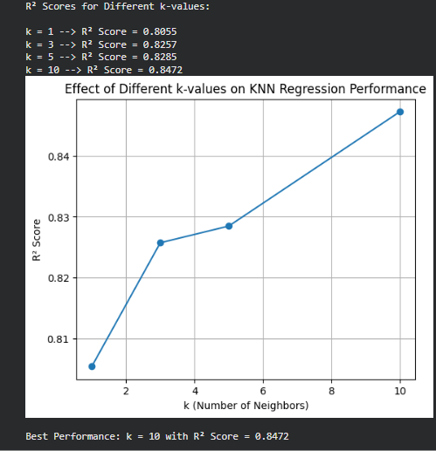
CODE:
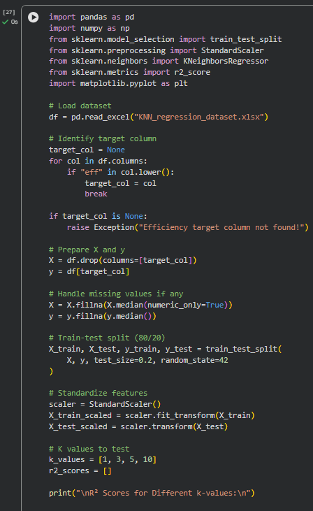 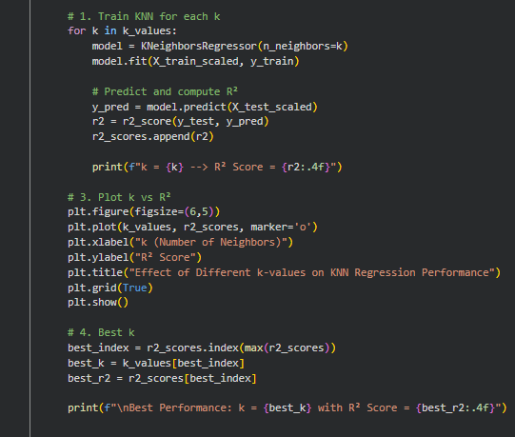

Marking Scheme 1 (10 marks):
  - Data loading & summary → 2 marks
  - Splitting & scaling → 2 marks
  - Training KNN model → 2 marks
  - Evaluation metrics → 4 marks
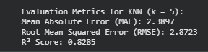

Marking Scheme 2 (10 marks):
  - Models for all k values → 3 marks
  - R² calculation → 3 marks
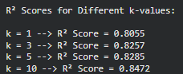
  - Plot (k vs R²) → 2 marks
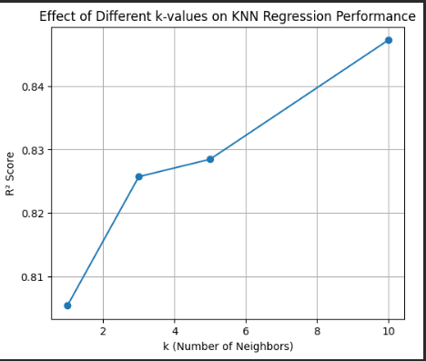
  - Best k → 2 marks

